Instructions:

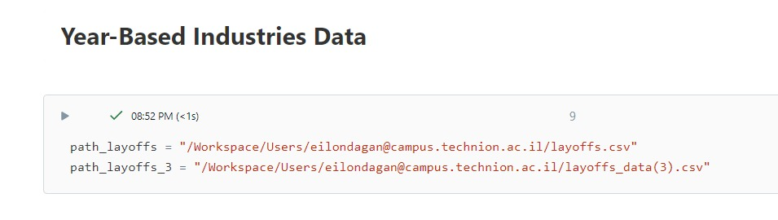

Put the additional data paths in this part of the notebook

Make sure to put the correct path for the moedel_weights file.

than run the code